**Homework 05: Fundamental Concepts Finale**

**PHYS550 – Quantum Mechanics I**

**Gabriel M Steward**

**September Oct 4-18, 2021**

***Additional Texts Referenced: Introduction to Quantum Mechanics, Griffiths and Schroeter***

**Problem 1.35**

*a) Verify 1.271a and 1.271b for the expectation value of p and p2 for the Gaussian wave packet 1.267.*

The Gaussian Wave Packet is given by:



While 1.271 states the following:



So we just need to manually evaluate the expectation value. For this we will need the complex conjugate of the Gaussian Wave Packet.



Since the wave packet is given in position space, we will need the values of p and p2 expanded as their operator forms. These are:



So we now find the expectation value via integration. Remember, integral is over all space, so while the bounds are left off it’s understood to be -∞ to ∞.

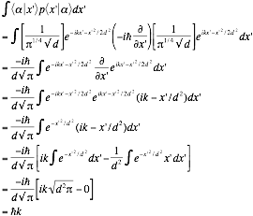

The actual integration step is accomplished through the known Gaussian integral: ∫e-a(x+b)^2=√(π/a). The second integral is an even function times an odd function which, by symmetry, has to integrate to zero. This confirms the expectation value of p.

|  |
| --- |
|  |

Now we do the same thing for p2 with almost exactly the same steps.

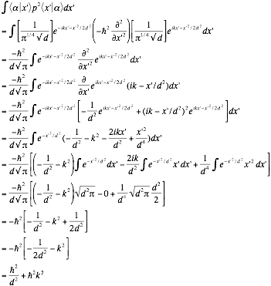

The only distinct step above was integrating the exp[]x’2 term, which was carried out using the example in 1.269 of the identical integral. Thus we have shown exactly what we set out to.

|  |
| --- |
|  |

*b) Evaluate the expectation value of p and p2 using the momentum-space wave function.*

Now we do it again but with the Gaussian in momentum space. The Gaussian here is given by 1.274:



In momentum space, this has no imaginary components at all, and as such is its own complex conjugate. This simplifies our math considerably. Start with p again.

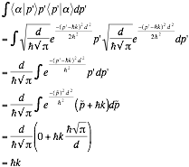

Which is exactly what we expected.

|  |
| --- |
|  |

Do it again, but squared.

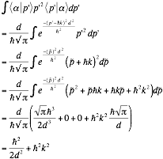

As before the squared portion of the integral was evaluated via 1.269, treating d2/ћ2 as 1/d2. Once again this is exactly what we sought to show, and we are finally done.

|  |
| --- |
|  |

**Problem 1.36**

*a) Prove the following where and  are momentum-space wave functions.*

*i) *

Since we don’t know x=iћ∂/∂p’ yet, we can’t just perform the substitute. We are tempted to use wavefunction notation since this was proved in our undergrad course, but let us try to stick with bra-ket. Insert some complicated ones into the original function.

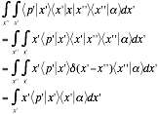

We note that  is the complex conjugate of  which, by equation 1.264, has the value of:



So we can make a substitution of:

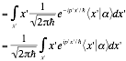

The next step is slightly unintuitive. We note that:



Which allows us to make a rather strange substitution.

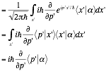

Thus

|  |
| --- |
|  |

*ii)*

We start with a rather obvious series of substitutions:

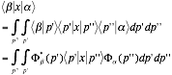

Then we use the result of part i) to continue further.

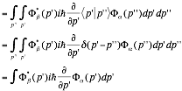

Which is what we sought to show.

|  |
| --- |
|  |

*b) What is the physical significance of where x is the position operator and Ξ is some number with the dimension of momentum? Justify your answer.*

The main use of the function **is to convert from one operator to another, specifically x to p (or vice versa). In the case of **, this would be conversion between x and Ξ. Ξ itself clearly represents some kind of momentum operator—though specifically what one is anyone’s guess, meaning that **can be used as a conversion function between position-space and some kind of transformed momentum space.